**Matlab HW1 Report**

**電機二 B09602017 白宗民**

(a)

Figure x1[n] vs n:

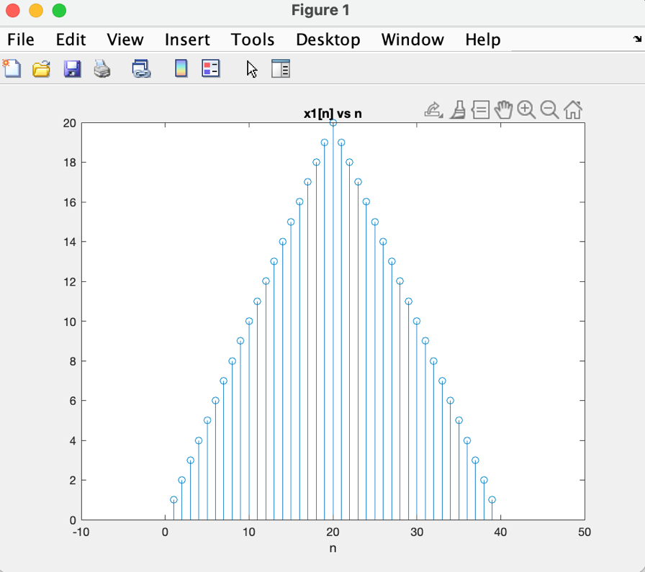

Figure x2[n] vs n:

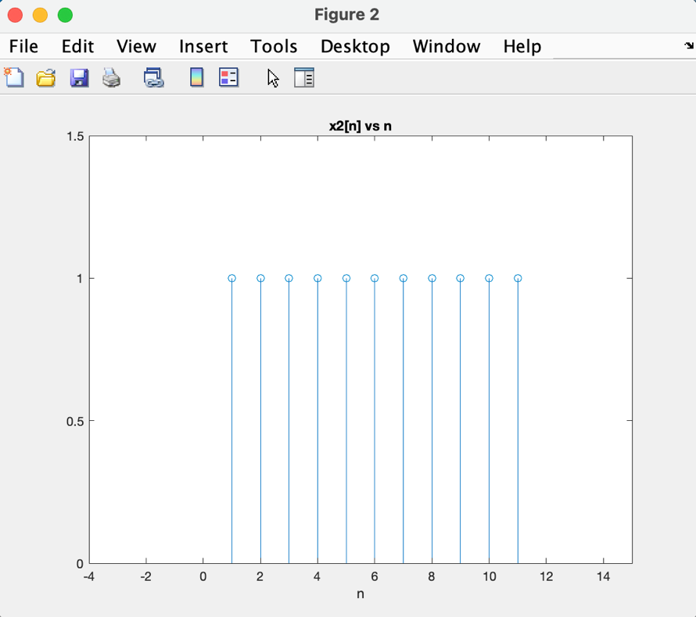

(b)

Figure y[n] vs n (convolution):

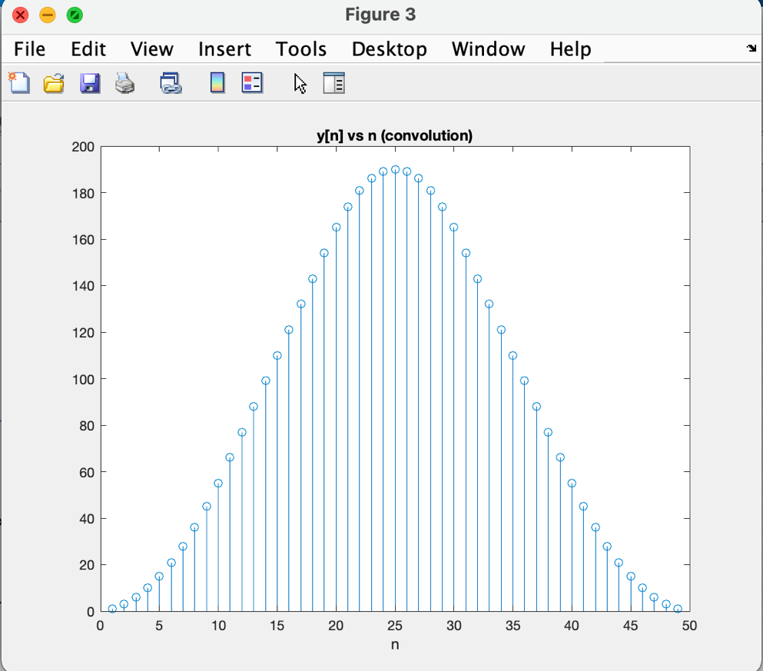

(c)

Figure y[n] vs n (matrix form):

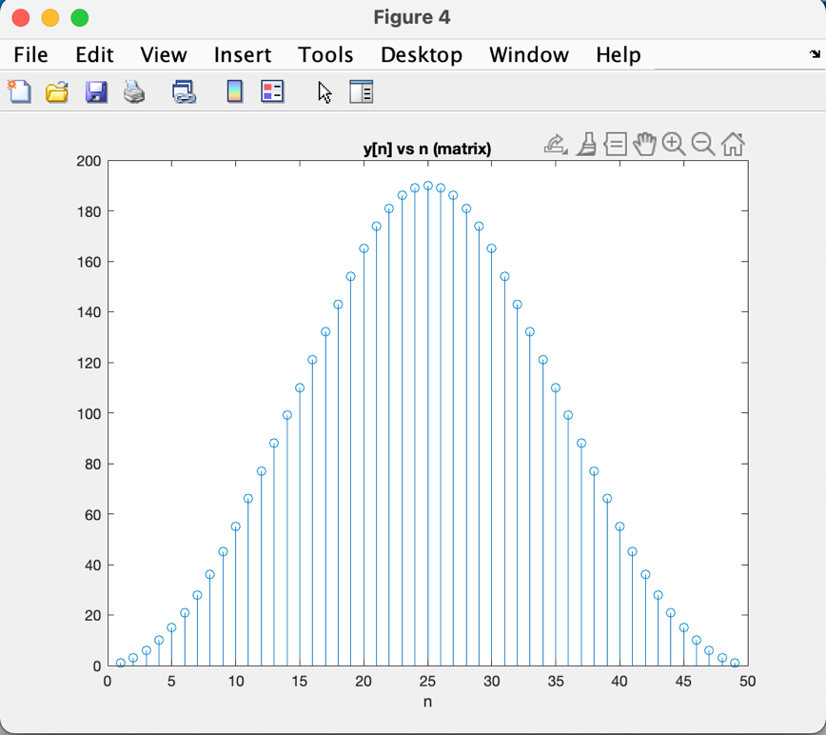

(d)

Figure x3[n] vs n:

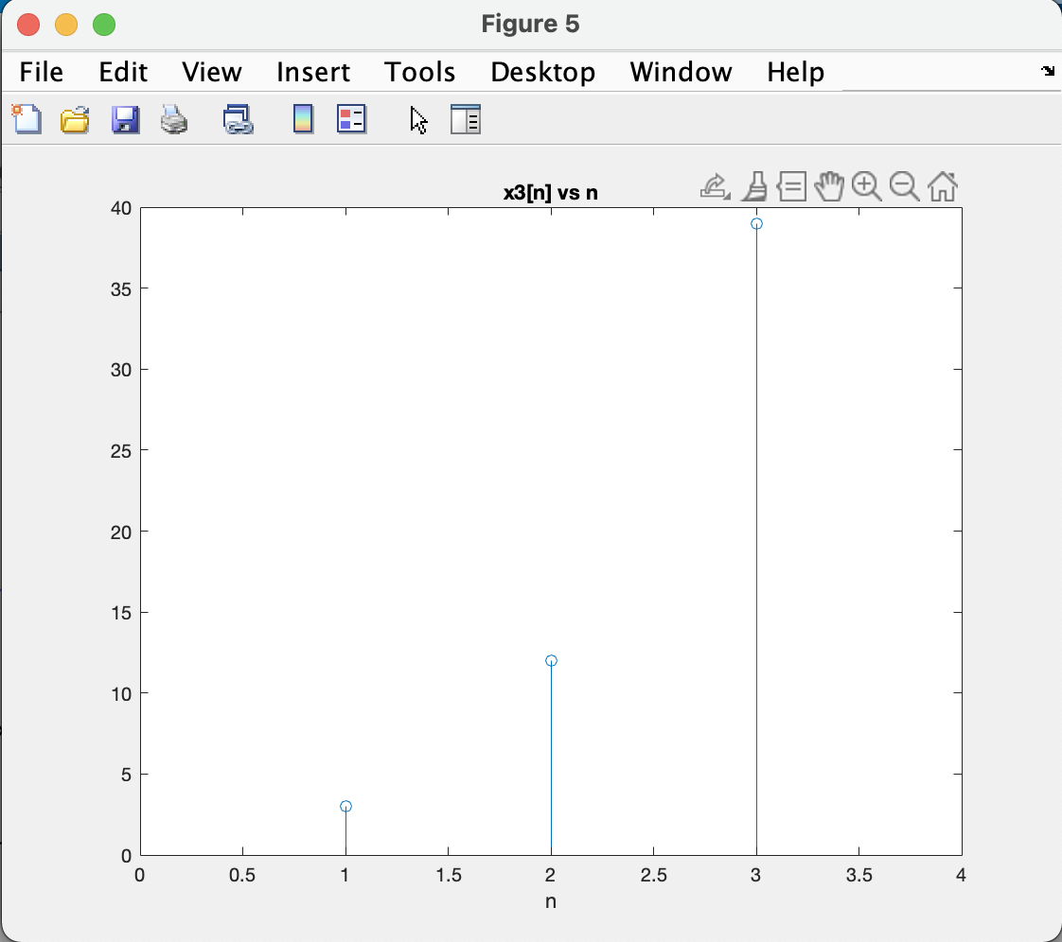

Figure x4[n] vs n: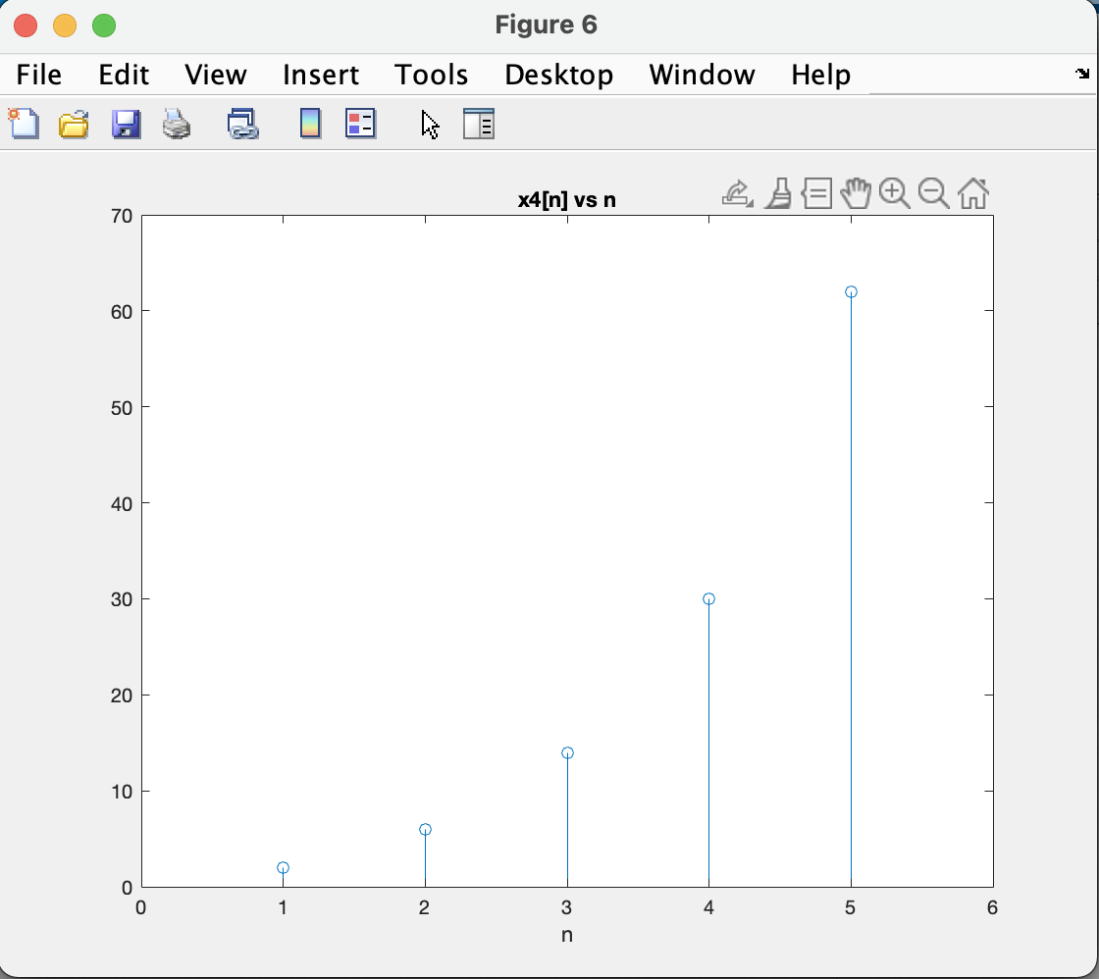

Figure y2[n] vs n (convolution):

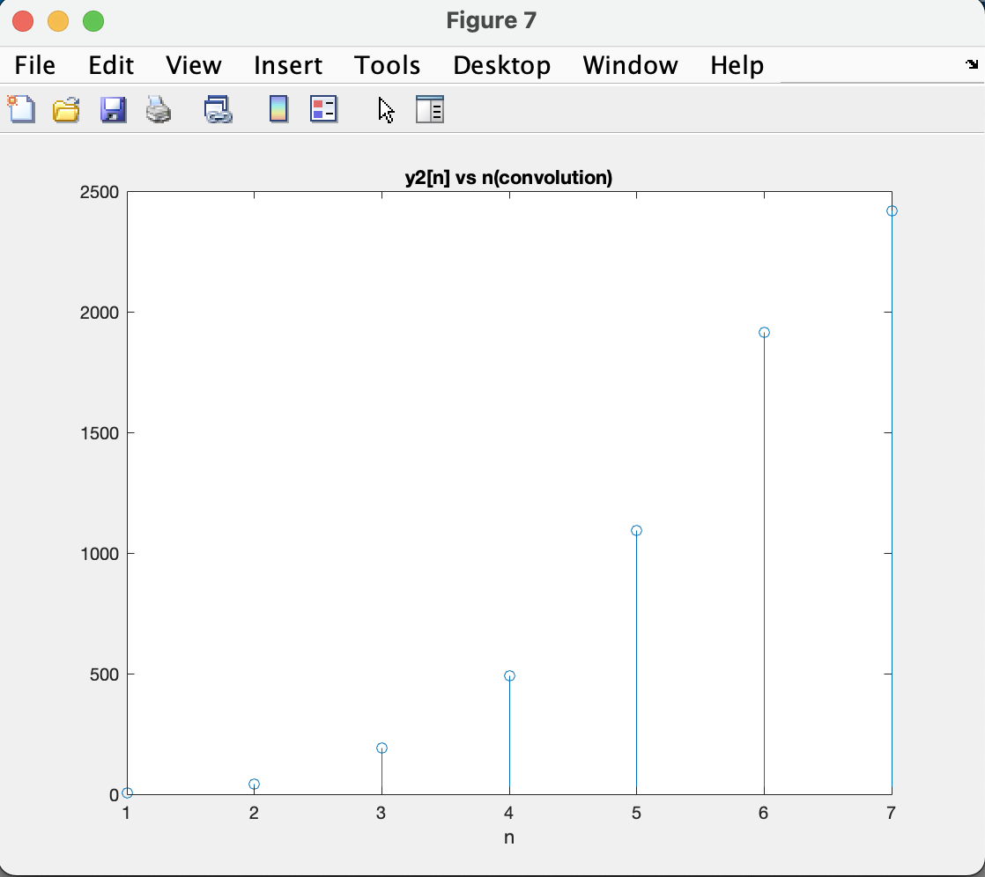

Figure y2[n] vs n (matrix):

